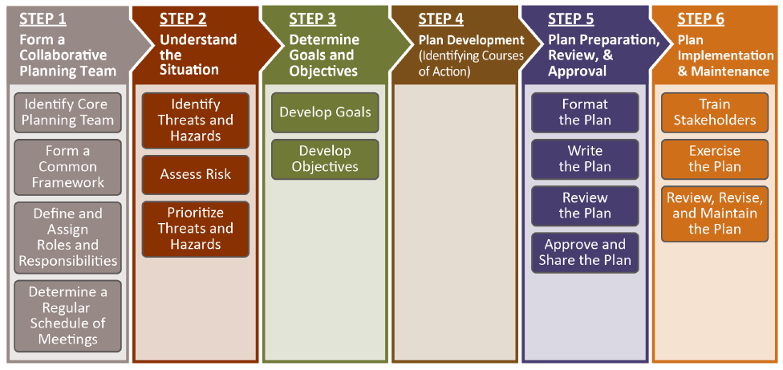
The Six Step Planning Process
Building-Level Emergency Response Plans:
consider what information is CONFIDENTIAL and determine who has a NEED TO KNOW
Preparing Team Meeting Agendas

A clear, purposeful advance agenda that includes all team members is key to making sure that safety planning remains a top priority and team motivation and meeting attendance stays high throughout the year.

Determine how often the team should meet and plot out the core agenda items for each month.

Make sure your meetings stay grounded in your core implementation goals.
- What action steps need to take place this school year to accomplish your goals, and when will they need to happen?
- How will the team measure progress toward goals?
- Who will be responsible for collecting data or documentation for the next meeting, and when can the team gather and reflect on benchmark data to practice continuous improvement?

Expect that incidental agenda items will arise throughout the year as well – we recommend setting up a structure for all team members to contribute additional agenda items in advance of each meeting to stay responsive to needs as they arise and to promote equity of voice among the team.

Each Team Member Matters!

Each team meeting agenda should include ways for every team member to contribute in a meaningful way. By intentionally setting up norms, routines, and activities that build an inclusive team culture, team members will be more likely to prioritize meetings and the tasks that take place outside of meetings. This also helps to ensure that the team’s work reflects diverse perspectives and tends to reduce the workload for the team leader. We recommend that teams:
- Set aside time at the first meeting to co-develop team norms.
- Create a rotating list of roles to share responsibilities among team members.
- Incorporate the 3 Signature SEL Practices into each meeting

Use a chart like the example below to sketch out how your team will advance the school’s plan and engage in continuous improvement over the course of the school year.

 | July | Aug. | Sept. | Oct. | Nov. | Dec.
Core Agenda Items
Team
Action Steps

- Benchmarks
- Deliverables
- Data
Plans for Continuous Improvement

 | Jan. | Feb. | March | April | May | June
Core Agenda Items
Team
Action Steps

- Benchmarks
- Deliverables
- Data

Plans for Continuous Improvement

Sample Team Meeting Checklist

Before
❏ Schedule meetings in a regular, repeating pattern, at least once monthly, for the entire school year (example: every other Tuesday).

❏ Develop an agenda in advance that reflects the school’s goals and action plan.
❏ Request additional agenda items from team members.
❏ Gather and summarize data for the team to use to monitor progress toward goals and make real-time pivots for continuous improvement.

❏ Send out the finalized agenda and a meeting reminder to team members at least one day in advance.
❏ Choose a welcoming and closure activity to be used at the beginning and end of the meeting.
During
❏ Use a welcoming activity to begin the meeting.
❏ Review the list of action items from the previous meeting and update progress.
❏ Review and reflect on relevant data for continuous improvement. Consider the time it might take to talk through the story that data tells about implementation progress.

❏ Collaborate to make progress on planned action steps to meet goals.
❏ Determine tasks that need to be completed and assign team members and due dates to each.
❏ Agree on what needs to be communicated to or asked of the larger school community.
❏ Agree on and capture what needs to be addressed at the following meeting.
❏ End with an optimistic closure.
After
❏ Send meeting minutes and next steps to the team and other stakeholders.
❏ Have team members communicate agreed-upon information to their stakeholder groups.
❏ Remind team members of their assigned action item(s).

TOOL: Sample Team Agenda

Date: ______________ Location: ______________ Time: ______________
Team members present:
Team norms:

Welcoming activity | Activity description or circle question identified
Data to inform discussion and planning | Can be planned benchmark data, stakeholder feedback, or data to help frame an issue for problem-solving
Core agenda items | Agenda Item A |  | Objective
 | Agenda Item B |  | Objective
 | Agenda Item C |  | Objective
Additional agenda items added by team members | Item A
 | Item B
Next steps | Action A |  |  |  | Person responsible
 | Action B |  |  |  | Person responsible
 | Action C |  |  |  | Person responsible
Key info to be communicated to staff/students/families/community | Item A |  |  |  | Person responsible
 | Item B |  |  |  | Person responsible
Follow-up/new items for next meeting | Description
Next meeting date and location | Date/Location
Optimistic closure | Activity description or circle question identified

